Day in the Life of the Hudson River 10/13/22
Hudson Shores Park, Watervleit
RIVER MILE: 152
Salt Front: ~ RM76
North Colonie CSD Learning Enrichment Program– Amy Parks
64 students & 7 adults
Latitude 41.471°N & Longitude –74.016°W

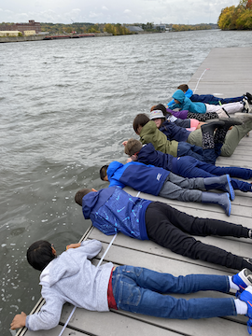 | 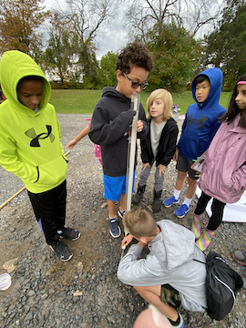 | 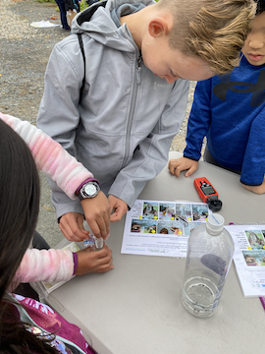

Location: Hudson Shores Park, Watervleit, Albany County, NY
Area: Public park area with walking path and boat dock used mostly for college crew teams
Sampling Site: Grassy, parking lot, riprap (large rocks), pipe entering the water
Surrounding Land Uses: 85% Industrial/Commercial, 5% Urban/Residential, 10% Recreational
Shoreline: 10% Sandy, 90% Rocky
River Bottom: Rocky
Water: Choppy
Plants in the Water: No plants
*NR = Not read/recorded
ITEM |  | Time |  | Reading |  |  |  | Comments
Physical
Air Temperature- |  | 9:46 AM  10:57 AM  12:55 PM |  | 22.18°C  20.3°C  22.8°C |  |  | 71.9°F  68.7°F  73°F
Wind Speed: *note seems very windy! |  | 11:01 AM |  | Anemometer  19.9 mph |  |  | Beaufort  5 | Direction  S
Weather today |  | 10:57 AM |  | >75% cloud cover |  |  | No Rain
Weather the past 3 days: |  | No rain, highs in the 60s, lows in the upper 40s  Not much rain
Tides- |  | Time |  | Rising, Falling, Unchanged |  |  | Water Height (cm)
*Measured to marker |  | 8:45 AM  10:03 AM  10:50 AM  11:15 AM  12:04 PM  12:56 PM  1:10 PM |  | Put in marker  Falling continuously all day |  |  | 370.84 cm  497.84 cm  558.8 cm  687.07 cm  848.36 cm  914.4 cm
Current- |  | Time |  | Cm/sec |  | Knots | North/South | Ebb/Flood/Still
 |  | 9:55 AM  10:24 AM  10:42 AM  11:08 AM  12:30 PM  1:10 PM |  | 15.5  11.2  23.8  22.7  18.85  29.27 |  | 0.3  0.4  0.37  0.57 | NR | Ebb  Ebb  Ebb  NR  Ebb  NR
Water Temperature- |  | 10:00 AM  11:05 AM  12:30 PM  1:05 PM |  | 14.5°C  18.5°C  16.5°C  15.25°C |  |  | 58.1°F  65.3°F  61.7°F  59.45°F
Turbidity- Long Sight Tube (120 cm) |  | 10:22 AM  11:11 AM  12:38 AM |  | 109.12 cm  118.16 cm  116.67 cm
Chemical
Salinity-LR Quantab |  | 9:50 AM  12:32 PM |  | 24 ppm Cl-  24 ppm Cl- |  |  | 1.3 quantab units | 43 ppm total salinity  43 ppm total salinity
Standardized Salinity – NR
DO – Hach Drop Count Kit |  | Time  9:50 AM  11:05 AM  12:37 AM |  | Temp  20°C  18.5°C  19°C |  |  | ppm DO  8 ppm  9 ppm  10 ppm | % saturation  90%  95%  105%
pH – Color Match Kit |  | 11:05 AM |  | 7.4
Nitrates- NR
Phosphates- NR
Alkalinity- NR
Biological-
Fish – Did not catch any fish – 16 hauls |  | Number |  | Name |  |  | Length of longest | Length of smallest
9:45 AM-1:30 PM
Fish Totals |  | TOTAL: 0 |  | Diversity: 0
Macroinvertebrates |  | Number |  | Name |  |  | Length of longest | Length of smallest
Macroinvertebrate Totals |  | TOTAL: 0 |  | Diversity:0
Sediment Core – NR
Length | H2S smell |  | Oxid Top |  | Oil |  | Grain Size | Other Features
Boats-
 | Time |  | Name |  | Color |  | North/Southbound | Light/Loaded
Commercial | 12:04 PM |  | American Independence |  | White |  | Southbound | Light
Recreational | 10:40 AM |  | Lemon Drop |  | White |  | Northbound | Light

